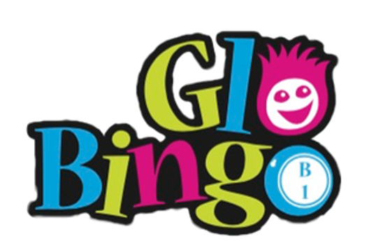

Ss. Peter and Paul School
Glo Bingo

Friday,
April 13, 2018

Ss. Peter & Paul Gymnasium 210 N Morrison Collinsville, IL
Doors open at 6:00 p.m. Bingo begins at 7:00 p.m.
Must be 18 or Older to Attend
*6 bingo cards, glow hat, & glow dauber* *Raffles * DJ

Contact Information: Susannah Arana; (618)407-0885; susannah.arana@gmail.com

Name: ______________________________________
Email: _____________________________________
Checks payable to SSPP Parents & Friends
- $160 per table of 8 players
- Sponsor a round $100
- Donate cash/items for raffle/prizes



