SS Peter and Paul Catholic School

November 15, 2019

Congratulations to our Honor Roll Students!
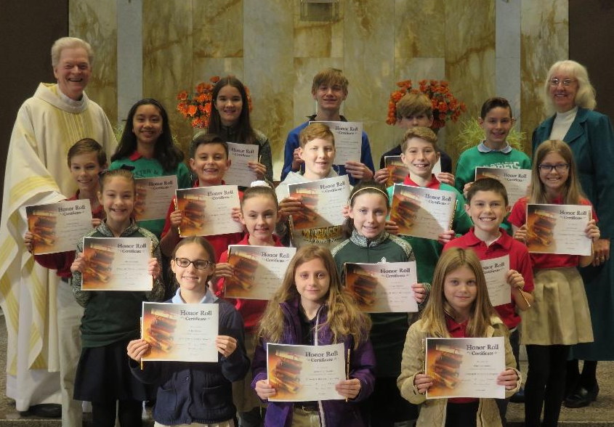
Principal’s Honors
First row: Skyla A., Gabrielle D., Elsa B.
Second row: Allyson R., Kaylee C.,
Gracie W., Owen W.,
Third row: Liam G., August K., William S., Matthew R., Tara D.
Fourth row: Joanne P., Hannah E., Christopher G., Lyle B., Lucas R.
Missing from picture: Landon B., Hannah S.
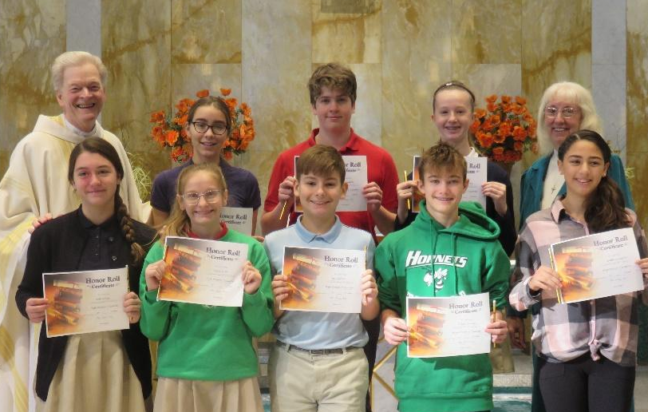
High Honors
First row: Molly R., Jenna G., Kai G.,
Robert F., Natalie P. Second Row: Emma B., John T., Katelynn B.

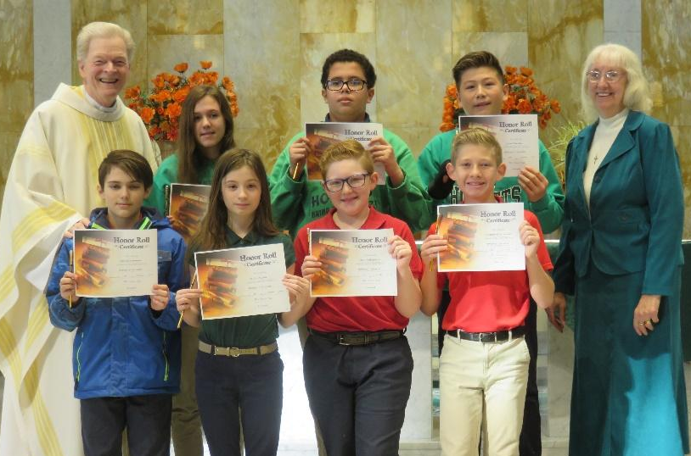

Honors
First row: Gabriel F., Faith K., Kolin W., Christopher M.
Second row: Bridget R., Khase G., Isaac W.

Last Tuesday was a surprise for a lot of school officials as well as parents. I want to remind you of the Inclement Weather Policy we have:

It is the policy of Ss. Peter and Paul to close school when Collinsville Unit 10 closes. School closings will be listed on Channels 2, 4 and 5. Parents will be called by the School Messenger System for notification. Please do not call the school or parish office for this information.

Virtual Days
For the last five years Ss. Peter and Paul has utilized what we call Virtual Days. When we have a cancellation, teachers Fast Direct and/or post assignments for students to work on just as if they are in school. In some cases, teachers will give packets of work ahead of time in anticipation of snow days. The Virtual Days have been approved by our Superintendent, Mrs. Brandi Borries from the Education Office of the Springfield Diocese. The assignments, especially for the students in grades 4 through 8, are centered on what would have been taught that day or a review of what has been taught. Students in Kindergarten through Grade 3 will be assigned review material. A new concept will not be assigned to any student. Students will be allowed two days for completing the virtual assignment. If in session, assignments are due the next day. However, the faculty has chosen to give an extra day for Virtual assignments.
Having Virtual Days allows us to keep our children learning even when not in attendance at school. If we did not do the Virtual Day assignments, it is possible that we would have to make up snow days at some time later in the school year. In a faculty meeting on Wednesday, the Virtual Day assignments were discussed and all faculty members felt the need to keep it the same as we have done for the past five years.

Parents & Friends is sponsoring the Vendor Fair tomorrow, November 16 in the school gym from 9 am to 2 pm. There are many different types of crafts that will be set-up. This would be a great time to do your first Christmas shopping. Hope you can come and look around.

Today is the closing of our mid-quarter for the second quarter. Mid-Quarter reports will be sent home next Friday, November 22nd.

Mrs. Plocher will be having Pre-School Parent/Teacher Conferences on Tuesday, November 19th and Thursday, November 21st.

Student Council Bake Sale on Monday, November 18th. Students will be able to purchase baked items for $0.25 each. Proceeds will fund the pizza treat for the winners of the Book Pumpkins.

Last week I wrote about the Extra Math Program that we will be using. I am proud to Congratulate the following students for passing the addition portal in answering facts under 3 seconds.
Eighth grade: Christopher G., Robert F.
Seventh grade: Ava G.
Sixth grade: Joanne P.
Third grade: Dedrick A., Will F.

These students will receive their Certificate of Achievement in Addition at the Tuesday mass, November 19th.

HELP! We need a Chess Moderator! If anyone plays chess or knows of a person (maybe a grandparent, uncle or aunt, cousin) that enjoys playing chess, please call me. We have students that like playing chess but we need an adult to be with them once a month for about an hour after school. The day can be chosen by the adult. Please ask around and see if you can help fill this need for us. Thanks.

Many Thanks to Mrs. Mary Beth Wilson who has taken over our Engineering Club. The students will meet once a month. Last Wednesday they built bridges to see which would hold the most weight.

Now that it is colder and Sew Time Embroidery in Maryville, Illinois has our logo, I asked them to give us a sample of the cost for long and short sleeve polo shirts and a sweatshirt with our school logo. These are available in forest green, red, and navy blue. This is not a mandatory order that you have to make. Sew Time Embroidery 618-345-6645
Store Hours: Mon: 10-3
Tues.- Fri: 10-6
Sat: 10-1

Future Dates for you to Know: December 6 - Christmas program at 6:30 pm in school gym
December 9 – Holy Day mass for Immaculate Conception 8:15 am
December 12 – Advent Reconciliation at 12:30 in church
December 18 – Advent Rosary at 1:40 pm in church
December 20 – Early dismissal at 11:15 am for Christmas break
buses will be in the morning BUT NO BUS at
11:15 am

Blessings and Peace to your family,

